Abraham Sharum
May 7, 2024
Dr. Bright
CS1303
Report
Descriptive Statistics:
Based on the following descriptive statistics the standard deviations of the price, mileage and age are all higher than the means of the respective columns. For the remaining groups the standard deviations are lower than their column average. The most frequently seen price, mileage, age, cylinder count and fuel type is: $55,000 , 0 , 1, 4 , Gasoline respectively.
- Price (USD):
  - Mean: $162,990.23
  - Mode: $55,000
  - Median: $92,000
  - STD: $187,120.06
  - MIN: $1000,00
  - MAX: $999,900.00
- Miles:
  - Mean: 5.10*(10^4)
  - Mode: 0
  - Median: 4.22*(10^4)
  - STD: 5.61*(10^4)
  - MIN: 0
  - MAX: 1.60*(10^6)
- Age (Years):
  - Mean: 5.88
  - Mode: 1
  - Median: 5
  - STD: 5.16
  - MIN: 0
  - MAX: 68
- Cylinder Count:
  - Mean: 5.75
  - Mode: 4
  - Median: 2
  - STD: 2.19
  - MIN: 0
  - MAX: 12
- Fuel Type (Gasoline, Diesel, Electric):
  - Mode: Gasoline
Hypothesis:
- Correlation
  - H0: Of the combustion cars the one's with higher cylinder counts have no change in price.
  - HA: Of the combustion cars the, one's with higher cylinder counts are higher in price.
- Variability
  - H0: No significant variability/variability happens by chance.
  - HA: Significant difference in variance.

- ANOVA
  - H0: Of the combustion cars, mileage, car age, and fuel type have no effect on pricing.
  - HA: Of the combustion cars, mileage, car age, and fuel type influence pricing.
Tests Used:
- Columns Used
  - Price (Converted from AED to USD)
  - Vehicle Age
  - Miles (Converted from Km to mi)
  - Number of Cylinders
  - Fuel Type (Petrol renamed as Gasoline)
- Correlation
  - Used to see the correlation between price and cylinder count.
  - p-value = 2.32 * (10^-256).
  - p-value < 0.05 means there is a correlation between
  - reject the null
  - correlation coefficient = 0.34
  - moderate positive correlation
- ANOVA
  - Used to see if there is significant variance in price based on milage, age, and fuel type.
  - p-value = 0
  - p-value < 0.05
  - reject the null
- Variability
  - Used to see if the variance in data is due to chance.
  - p-value = 0
  - p-value < 0.05
  - variability is due to chance.
  - accept the null
Graph of the data:
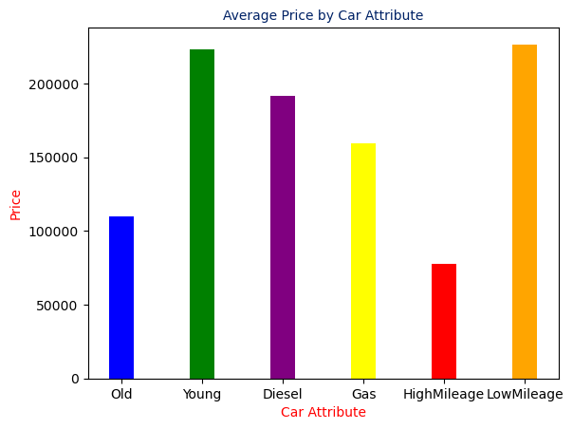

Link to CSV used:
- https://www.kaggle.com/datasets/azharsaleem/uae-auto-market-sales-data-for-advanced-analytics

